**MULTI DISEASE PREDICTION USING MACHINELEARNING**

Many existing machine learning models for health care analysis focus on a single disease. For example, one analysis could be for diabetes, another for cancer, and another for skin problems. There is no universal approach that can forecast multiple diseases using a single analysis. By utilising the Flask API, this project proposes a system that can forecast different diseases. Diabetes, heart disease, and breast cancer were all examined in this investigation. Other disorders, such as skin conditions, fever analysis, and a variety of others, can be added later. Using machine learning methods, tensor flow, and the Flask API, numerous illness analyses was implemented. The model behaviour is saved using Python pickling, and it is loaded using Python unpickling.

​​​As we are using various kinds of vast health data sets, this leads to need for a cloud for accessing the data So here we use cloud for our data access, then the remaining process get held by using the various Machine Learning Algorithms

**Existing system:**

“Disease Prediction System” used Decision tree, Random Forest and Naïve Bayes algorithms to predict a disease on the basis of systems and to enable synchronized and well-versed medical systems ensuring maximum patient satisfaction

Heart Disease Prediction with Machine Learning Approaches" made use of LR, NB,KNN,SVM,DT and RF algorithms for prediction of heart disease with proper data processing and implementation of ML algorithm with different parameters and among all Machine Learning algorithms, the highest accuracy is achieved by KNN with 87%.

”Heart Attack Prediction By Using Machine Learning Techniques" has compared various Machine Learning models with the help of performance metrics and to detect heart related problems with highest accuracy of 89.34% by SVM.

”Disease Prediction Using Machine Learning over Big Data” has proposed a CNN-MDRP algorithm which combines structured and unstructured data and proved that CNN-MDRP is more accurate than previous prediction algorithm.

**Disadvantages:**

* Existing system works for only single disease and for each type of disease use should visit multiple websites to get predict disease
* Existing methods use same algorithms for all disease predictons.

**Proposed System:**

We are proposing such a system that will flaunt a simple, cost effective , elegant User Interface and also be time efficient . Our proposed system bridges the gap between doctors and patients which will help both classes of users to achieve their goal. This system is used to predict below mentioned diseases

Diabetes

- Breast Cancer

- Heart Disease

- Kidney Disease

- Liver Disease

- Malaria

- Pneumonia

. In this proposed system we are going to take down six disease dataset from the Kaggle website and evaluate them by applying algorithms such as Decision Tree, Random Forest, Naïve bayes and KNN which will help in getting accurate prediction .Our system will explore and merge more datasets which includes large diversity of population to get more effective results and thus our system will improve and enhances the accuracy of the results. Along with the increased accuracy rate, we will proliferate the reliability of our system for this job and can gain the trust of patient in this system. Apart from all these, our system will comprise of a Database for storing the data entered by the users and the name of the disease the patient is suffering from which can be used as a reference in future for further treatment. Hence this system will contribute in easier health management with better satisfaction to the users.

**Advantages:**

* Single website is used to predict six type of diseases.
* Each disease is trained with different algorithms
* Time taken for training and prediction is less with high actuary**.**

**System Architecture:**

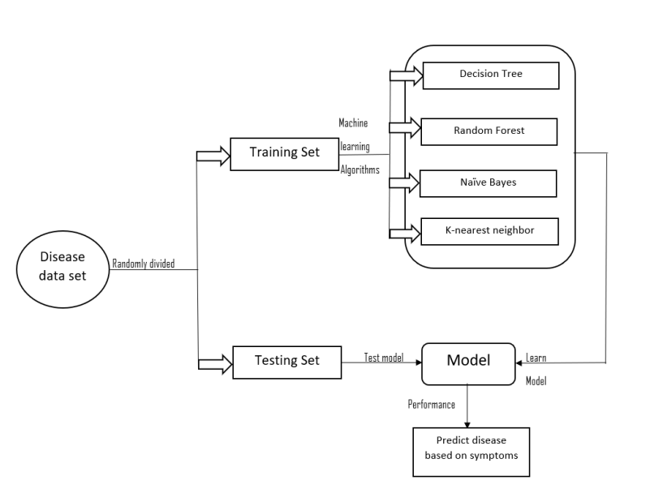

**Software Requirement:**

### HARDWARE REQUIREMENTS:

* System : Intel(R) Core(TM) i3-7020U CPU @ 2.30GHz
* Hard Disk : 1 TB.
* Input Devices : Keyboard, Mouse
* Ram : 4 GB.

### SOFTWARE REQUIREMENTS:

* Operating system : Windows XP/7/10.
* Coding Language : Python
* Tool : Anaconda
* Interface : OPENCV

**References;**

[1] Khurana, Sarthak . , Jain, Atishay ., Kataria ,Shikhar. ,Bhasin ,Kunal . , Arora ,Sunny . ,& Gupta , Dr.Akhilesh . Das. (2019). Disease Prediction System.International Research Journal Of Engineering and Technology , 6(5) , 5178-5184.

[2] Kamboj ,Mgha. (2020).Heart Disease Prediction with Machine Learning Approaches.International Journal Of Science and Research , 9(7) , 1454-1458.

[3]Ware,Miss.Sangya . , Rakesh,Mrs.Shanu. K.,&Choudhary,Mr.Bharat . (2020). Heart Attack Prediction By Using Machine Learning Techniques. International Journal Of Recent Technology and Engineering , 8(5), 1577- 1580. Turkish Journal of Computer and Mathematics Education __________________________________________________________________________________ 4023 Research Article Vol.12 No.6 (2021), 4013-4023

[4] Shirsath ,Shraddha.Subhash .,& Patil , Prof. Shubhangi . (2018).Disease Prediction Using Machine Learning over Big Data .International Journal Of Innovative Research in Science and Technology , 7(6), 6752-6757

[5]Marimuthu , M. , Abinaya, M. ,Hariesh,K.S., Madhan,K.,& Pavithra, Kumar. V.(2018).A Review of Heart Disease Prediction Using Machine Learning and Data Analytics Approach .International Journal of Computer Application , 181(18), 20-25.

[6] Battineni ,Gopi. , Sagaro,Getu.Gamo. ,Chinatalapudi, Nalini. ,&Amenta,Francesco. (2020). Application Of Machine Learning Predictive Models in the Chronic Disease .International of PersonalisedMedicine , 10(21), 1- 11